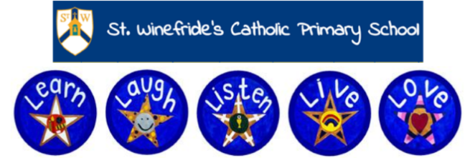

St. Winefride’s Catholic Primary School
Information for Year 1 Parents – Summer 2024

I am in:  Year 1 | My Class Teachers are:  Miss Wright  Mrs Williams

Through Geography and History, the topics I am focusing on this term are:
- Geography – Which beaches can I visit on the Wirral?
- History – How have holidays changed since the Victorian times?

Through My Religious Education lessons, I am considering: (from ‘The Way, the Truth, the Life).
- The Resurrection of Jesus
- Miracles
Through RSE (Relationships and Sex Education)- ‘Love to be me’ lessons we will look at
Module 3: Created to live in the community.
- Who is my neighbour?
- The community we live in.

In English I am working on:  A range of fiction, non-fiction and poetry: Toys In Space by Mini Grey Punctuate sentences using a capital letters and a full stop, some question marks and exclamation marks Use ‘and’ between words and some clauses Some accurate use of the prefix unSome accurate use of suffixes (where no change is needed to the root of the word) e.g. ed, -ing, -er, -est | In Mathematics I am working on:  - Place value (within 50)  - Multiplication and division  - Length and height  - Mass and volume  - Fractions  - Place value (within 100)  - Time

In Science I am working on:  - Seasons (Spring to Summer)  - Plants  - Investigation skills and recording | In computing I am working on:  - Digital Citizenship  - E-safety  - Digital Literacy: using a computer  - Coding

In P.E I am learning skills in:  - Athletics  - Games  - Gymnastics  - Dance | In Art I am creating:  - We will be studying portraits.  - We will be studying sculpture and looking at the artist Andy Goldsworthy. | In DT I am creating:  - The class will be looking at food and nutrition and making seaside snacks.

Some Useful Websites:
Maths
www.topmarks.co.uk
Reading
www.teachyourmonstertoread.co.uk
Key Stage 1 Science:
https://www.bbc.co.uk/bitesize/subjects/z6svr82
RSE information:
https://www.tentenresources.co.uk/life-to-the-full-primary/
History
https://www.fireoflondon.org.uk/

