
Religious Education
Spring First Half Term

Dear Parents and Carers,
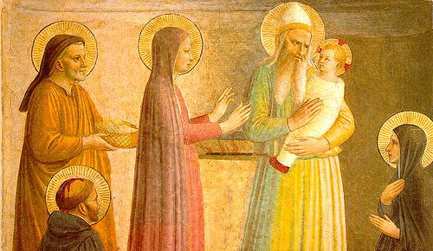
We begin this term full of the joy of the Christmas season which ends for us at the celebration of the Baptism of Jesus on 8th January. On the 2nd February we celebrate the feast of the Presentation of the Lord (Candlemas) when Jesus is recognised as ‘the light of the world’. We must also remember that each one of us is called to be a ‘light’, an inspiration to those around us.

In this issue of the newsletter you will find what your child is learning about in their year group. We hope you find this newsletter of interest and as always, please keep us in your prayers as we continue to support your children in their religious education.

Dates from the Church’s calendar:

6th January The Epiphany of the Lord 28th January St. Thomas Aquinas
12th January St. Aelred of Rievaulx 31st January St. John Bosco
8th January The Baptism of the Lord 2nd FebruaryThe Presentation of the Lord
17th January St. Anthony 3rd February St. Blaise
24th January St. Francis de Sales 8th February St. Josephine Bakhita
25th January Conversion of St. Paul 11th February Our Lady of Lourdes
26th January Ss. Timothy & Titus
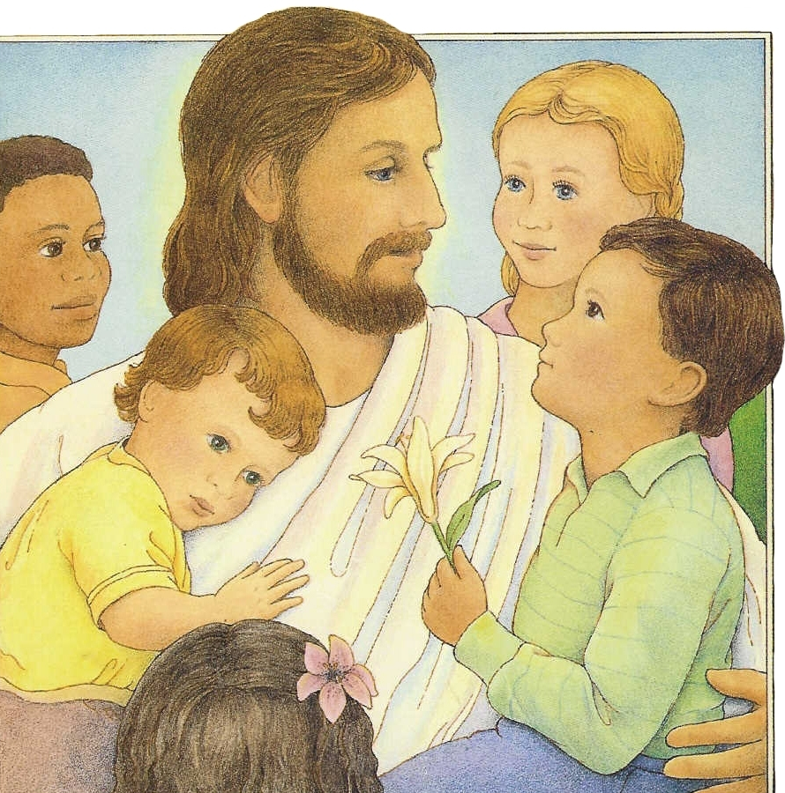
Reception – Getting to know Jesus

This half term, the children in our Reception class will be getting to know Jesus. Throughout the topic, the children will be given opportunities to become aware that Jesus has a great love for each one of us and will think of ways in which we can show our love for Jesus. They will hear that Jesus cured people who were sick and think of ways we can show our love for sick people.
At home
You could help your children by:
• saying or sharing prayers together.
• talk about people who help us e.g. nurses, doctors.
• talk about how we can help others.
• giving them jobs which help at home.

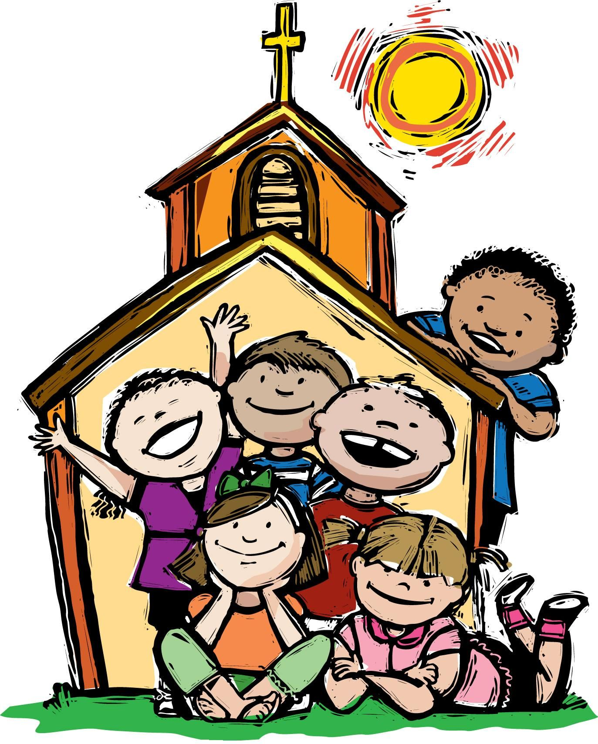
Year 1 – Families and Celebrations
“The Christian family …
can and should be called a domestic church.
It is a community of faith, hope and charity”
Catechism of the Catholic Church
The children will learn about what it means to be a member of a family and to be a member of the school community. They will learn what it means to belong to the Church family.

They will hear how Jesus’ family took him to the Temple and think about why this was a special occasion. They will learn about some of the celebrations in the Church and why we celebrate these occasions.

At home
You could help your children by:
• discussing the importance of celebrations in our lives.
• encourage children to think about Church celebrations e.g. Christmas, Easter etc.

Year 2 – The Good News
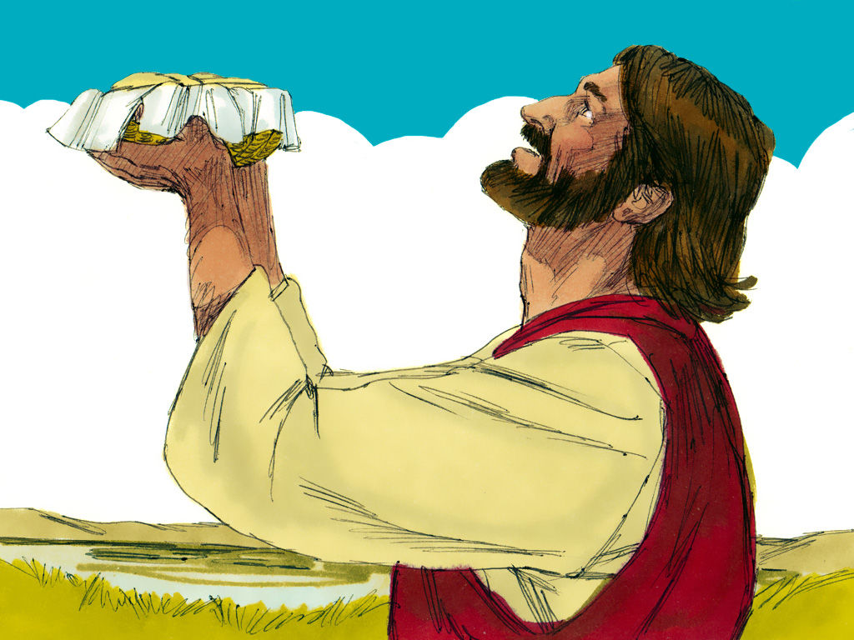
“Jesus is sent to preach good news to the poor. Jesus identifies himself with the poor of every kind and makes active love toward them the condition for entering his kingdom.”
Catechism of the Catholic Church
The children will learn that Jesus brought the good news of God’s love and that this changed people’s lives. They will learn that Jesus used his power to help others and reflect on the importance of these events.

They will reflect on how they can bring good news to their family and friends.

At home
You could help your children by:
• highlighting opportunities when they can give thanks to God.
• read stories about Jesus helping people, e.g. The feeding of the 5000.
• visiting www.tere.org/interactive_site/KS1link.htm and completing the activities.

Year 3 – Sacrament of Reconciliation
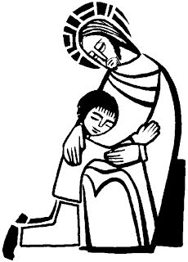
“During his public life Jesus not only forgave sins, but also made plain the effect of this forgiveness: he reintegrated forgiven sinners into the community … from which sin had alienated or even excluded them. A remarkable sign of this is the fact that Jesus receives sinners at his table.”
Catechism of the Catholic Church
The children will develop their understanding that Jesus called people to change, to turn away from sin and receive the love of God. They will learn that it is not always easy to change and find out about some individuals who changed through the help of Jesus.

They will learn that the Sacrament of Reconciliation is a celebration of God’s love and forgiveness and begin to learn an Act of Sorrow. They will learn that Lent is a time to change in order to prepare for Easter.

At home
You could help your children by:
* thinking about how Jesus changed our lives.
* reading the story of Zacchaeus.
* going online to www.tere.org/interactive_site/KS2link.htm and completing the interactive activities.

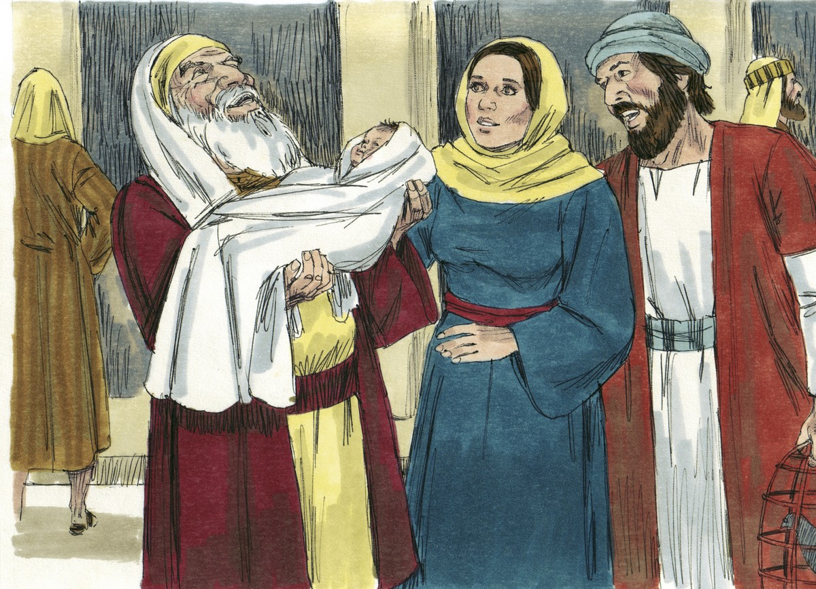

Year 4 – Jesus the Teacher
The children will learn that Jesus was born into a Jewish family and find out about the story of the presentation in the Temple.
They will learn that Jesus attended synagogue as a child and as an adult read the Torah. They will learn that Jesus travelled around teaching people.

The children will learn that Jesus came to show us the way to live, understand why
Jesus used parables to teach people and know and understand some of the parables
Jesus told. The children will have a chance to appreciate the relevance of the parables
for us today and recognise that Lent gives us an opportunity to live as Jesus wants us to.

At home
You could help your children by:
* reading some well-known parables, e.g. ‘The Sower’ and talk about what they mean for us.
* going online to www.tere.org/interactive_site/KS2link.htm and completing the interactive activities.

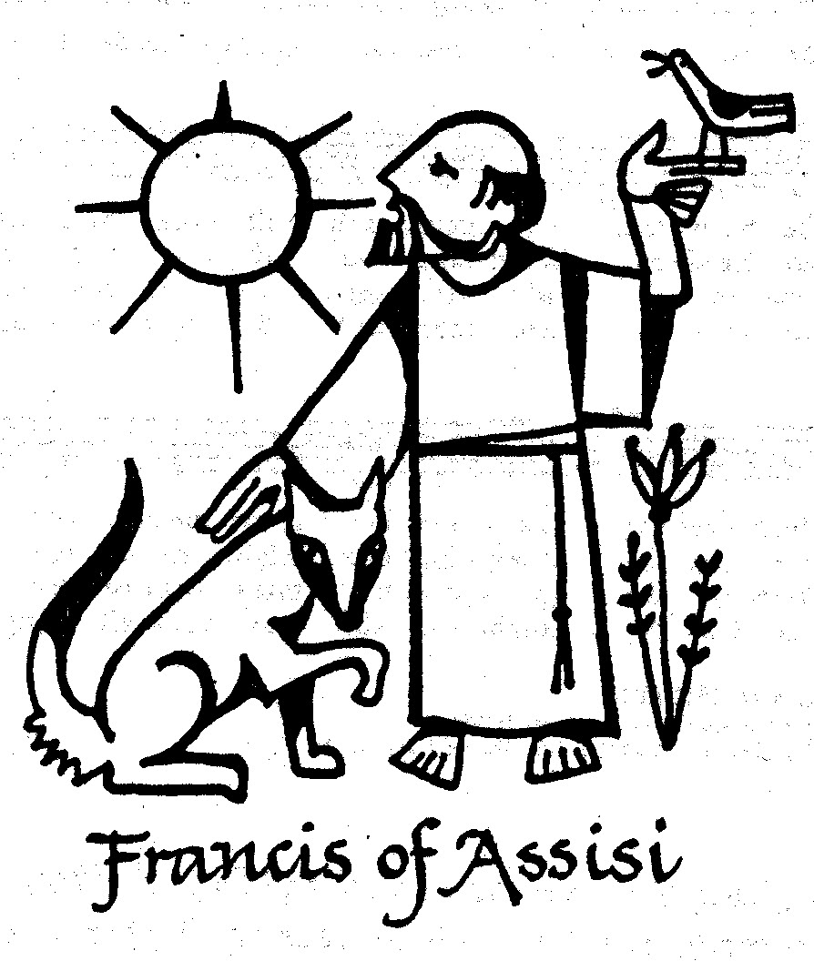
Year 5 – Inspirational People

“Love of neighbour … involves working for a just society… It includes love for the poor. Love of neighbour is also an expression of our search for God.”
Religious Education Curriculum Directory
The children will learn about the conditions for following Jesus and learn how Jesus described a true disciple. They will have a chance to reflect on their commitment to following Jesus.

They will learn the story of a person who had a special love for those rejected by society and about someone who was an inspiration for young people. They will identify people today who are an inspiration in their service of others.

At home
You could help your children by:
* encouraging them to research some information about inspirational people and saints.
* going online to www.tere.org/interactive_site/KS2link.htm and completing the interactive activities.

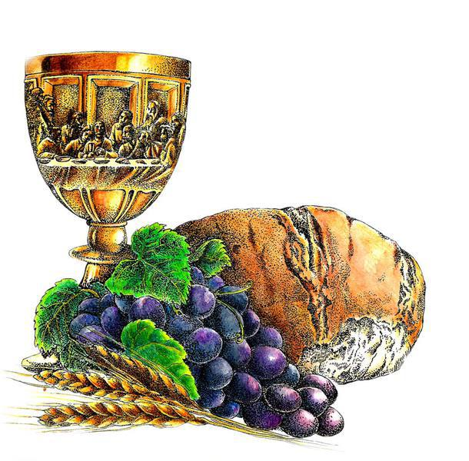
Year 6 – Exploring the Mass
“At the heart of the Eucharistic celebration are the bread and wine that become in reality Christ’s Body and Blood. Catholic faith adores this enduring presence of Christ not only within the celebration of the Mass but also outside it.”
Religious Education Curriculum Directory
The children will learn that the Sacrament of the Eucharist is a thanksgiving for the life, death and resurrection of Jesus. They will begin to understand that in the Mass we participate in Jesus’ sacrifice to God the Father and learn what happened at the Last Supper.

They will learn the different parts of the Mass and become familiar with most of the responses. The children will learn that the bread and wine are consecrated during Mass and become the body and blood of Jesus.

The children will have a chance to reflect on the sacrifice of Jesus and reflect on the sacrifices they can make during Lent.
At home
You could help your children by:
* bringing their attention to the Eucharistic prayer during Mass.
* asking them during the week to explain what they have been learning during their Religious Education lessons.
* going online to www.tere.org/interactive_site/KS2link.htm and completing the interactive activities.

