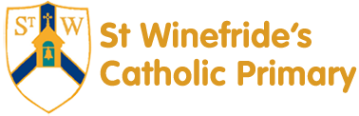
Religious Education 2018
Spring Second Half Term

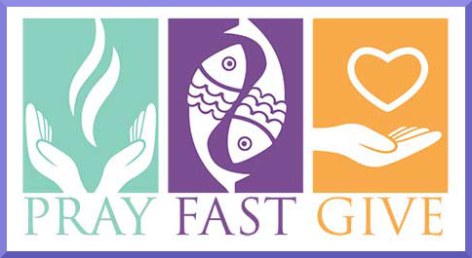
Dear Parents and Carers,
The word Lent comes from an old English word that means ‘lengthen’ and refers to the turning of Winter into Spring when the days lengthen and the cycle of life, by the grace of God, is being renewed once more. There are so many things around us during this season to be thankful for. There is more sunlight, birdsong is more noticeable, daffodils are beginning to grow and trees are beginning to show signs of coming to life. These signs of new life are echoed in the season of Lent through which the Church bids us to reawaken our spiritual sensibilities and refocus on tending to the Lord who calls us ‘come back to me, with all your heart’. Lent, beginning with Ash Wednesday, brings to the forefront of our consciousness the importance of thankfulness for everything, including life itself which is a pure gift. The journey of Lent is a journey towards the new way of living that Jesus, through the Holy Spirit, promised to us through the power of our most celebrated season – Easter and the Resurrection of Jesus.

We tend to think that Christmas is the most important time in the Church’s year, but the Resurrection of Jesus is by far the most important for Christians. When we as Christians say that our hope is in the risen Jesus, we mean it is our greatest hope. When Jesus rose on the first Easter morning, it was a brand new kind of life. He promises this same life to all who hope in him. No wonder that Easter is the greatest feast!
“That you may not grieve as others do who have no hope”
1 Thessalonians 4: 13

We hope, as always, you find this newsletter interesting and informative. Please keep us in your prayers as we support your children in their Religious Education.

Dates from the Church’s calendar:

14th February Ash Wednesday 19th March St. Joseph(transferred)
18th February First Sunday of Lent 25th March Palm Sunday
25th February Second Sunday of Lent 29th March Maundy Thursday
4th March Third Sunday of Lent 30th March Good Friday
11th March Fourth Sunday of Lent 31st March Holy Saturday
17th March St. Patrick (Patron of Ireland) 1st April Easter Sunday
18th March Fifth Sunday of Lent

Reception— Joy and Sorrow
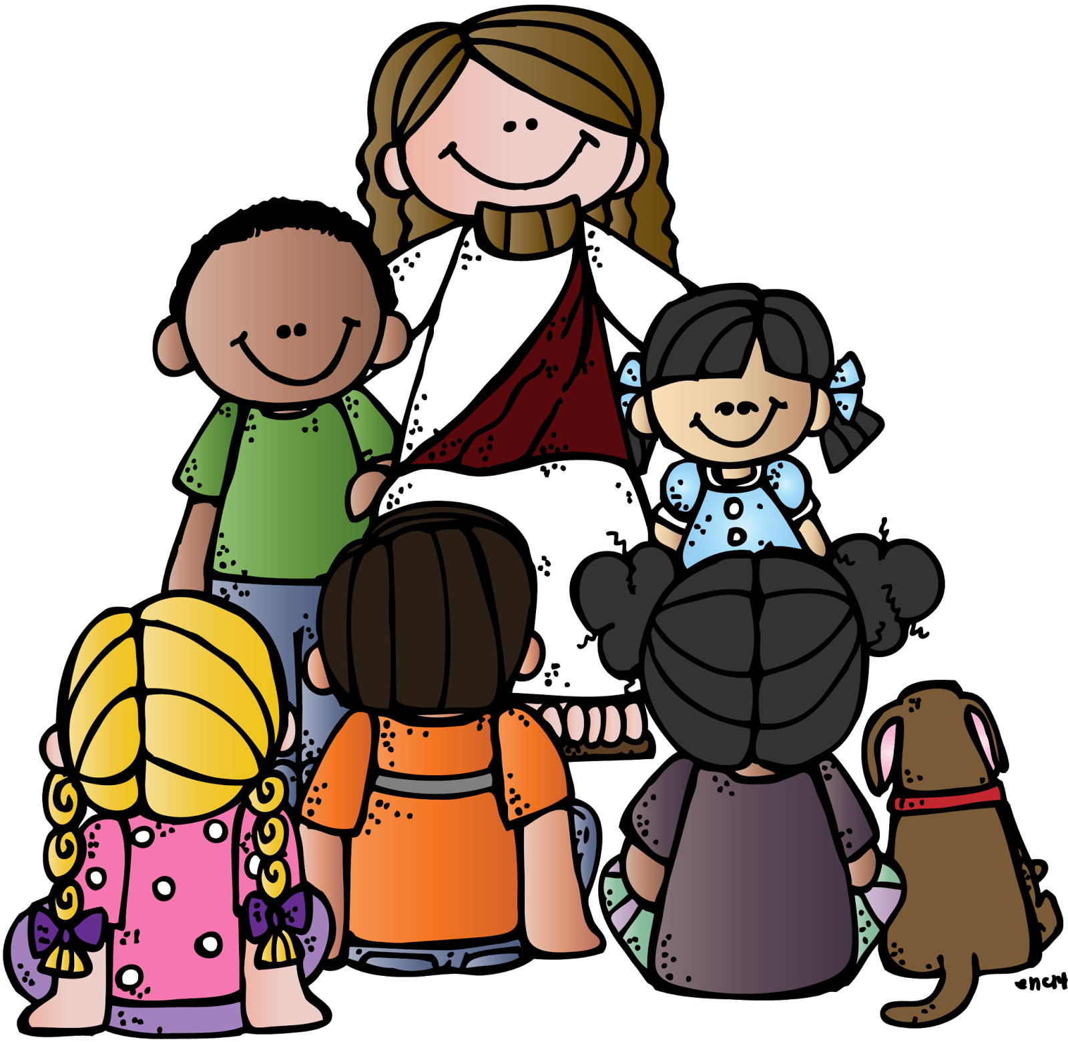
There is no limit to God’s grace, nor to God’s mercy when we fail.
Religious Education Curriculum Directory

This half term, the children our Reception class will be learning about joy and sorrow. They will begin to understand that we are capable of hurting others and that we should always try to be kind to each other. They will learn that we can say sorry when we hurt someone but we need to ask Jesus to help us to do this. They will also begin to learn that Jesus forgave those who hurt him and know that we can forgive other people when they hurt us.

At home
You could help your children by:
• talking to them about what makes them happy
• talking to them about how they can be kind to other people
• reminding them to say please and thank you and to say sorry when it is appropriate

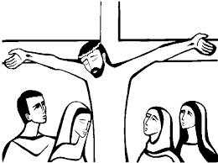

Year 1—Following Jesus

“From the beginning, Jesus associated his disciples with his own life, revealed the mystery of the Kingdom to them and gave them a share in his mission, joy and sufferings.”
Catechism of the Catholic Church

Year 1 will hear how Jesus chose some of the first disciples (Luke 3. 5: 1- 11) and reflect on how we choose our friends. They will hear how Martha and Mary were friends of Jesus and think about how we can be his friends. They will listen to the story of Jesus and his followers going into Jerusalem and think of how we can praise Jesus. They will learn that Jesus died on Good Friday and know that God raised Jesus from the dead on Easter Sunday.

At Home
You could help your children by:
•Encouraging them to invite a friend to play

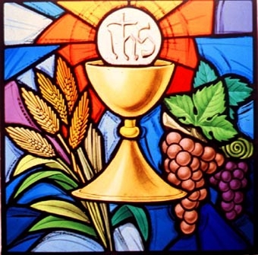
Year 2—The Mass
“In the Eucharist we receive him as our life and food, a promise of the eternal banquet of heaven. At the heart of the Eucharistic celebration are the bread and wine that becomes in reality Christ’s Body and Blood. Catholic faith adores this enduring presence of Christ not only within the celebration of the Mass but also outside it.”
Religious Education Curriculum Directory

Year 2 will learn and reflect on the importance of the celebration of the Mass. They will learn about the readings at Mass and why we should listen to them, and learn that at the Offertory we offer gifts to God. They will also appreciate that at the Consecration the bread and wine are changed into Jesus.

At Home
You could help your children by:
• reading some bible stories with them

Year 3—Eucharist
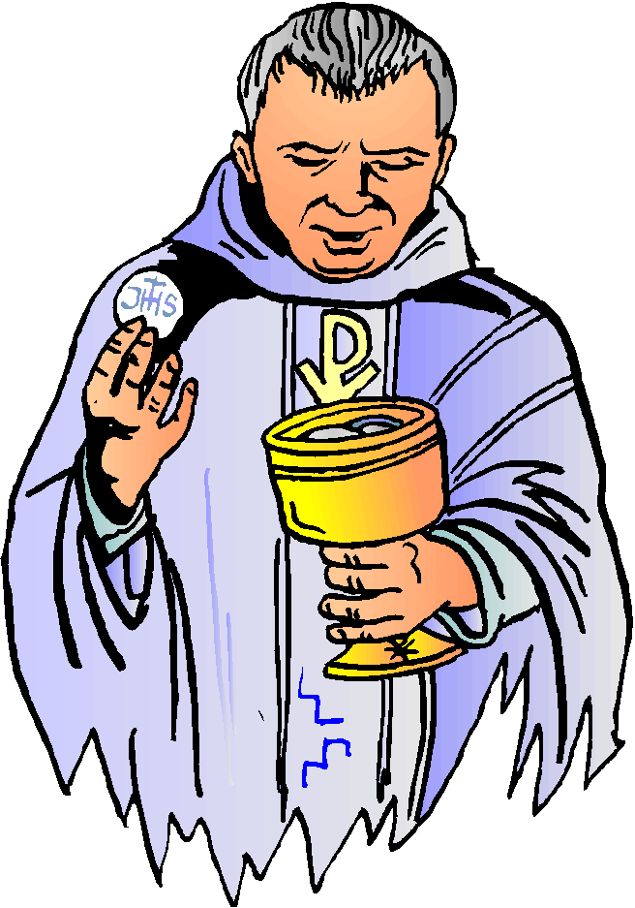
“In the Eucharist we participate in the Lord’s sacrifice. We are joined to the eternal praise and thanksgiving he offers as Son of the Father, and to his sacrifice on the cross. We receive him as our life and food, a promise of the eternal banquet of heaven. At the heart of the Eucharistic celebration are the bread and wine that become in reality Christ’s Body and Blood. Catholic faith adores this enduring presence of Christ not only within the celebration of the Mass but also outside it.”
Religious Education Curriculum Directory
Year 3 will know why Sunday is special for Christians and will know that we come to Mass to hear the teaching of Jesus and pray to him. They will learn that in the Mass we offer thanks to God the Father for the gift of his Son and learn that during Mass the bread and wine become the body and blood of Jesus. They will learn that when we receive Holy Communion we receive Jesus and learn that Jesus is present in the Blessed Sacrament in the tabernacle. They will also learn some of the responses in the Mass and understand that Jesus died on the cross, and rose from the dead.

At Home
You could help your children by:
• talking to them about all the things we have to be thankful for
• talking to them about how Sunday is a special day for Christians
• visiting www.tere.org/interactive_site/KS2link

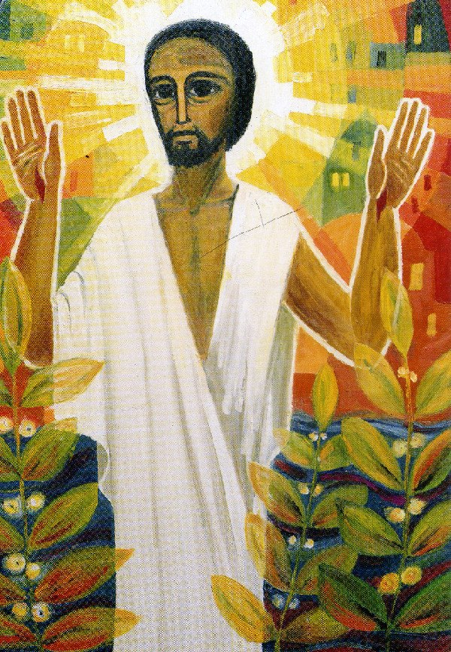
Year 4—Jesus the Saviour

Jesus “is truly God and, as a man, truly human. His life, death and resurrection are the central event of all human history and at the heart of faith. His cross is the sign of his unique offering of himself for each and every human being.” Religious Education Curriculum Directory

Year 4 will learn that Jesus is truly God and, as man truly human and learn that Jesus came to share our life so that we can share his life. They will learn that when Jesus died on the cross he took away our sins, learn what happened in Holy week an learn what happened on Easter Sunday.
At Home:
You could help your children by:
• reading the stories of Jesus’ last week with them
• visiting church during Holy Week
• visiting www.tere.org/interactive_site/KS2link

Year 5—Reconciliation
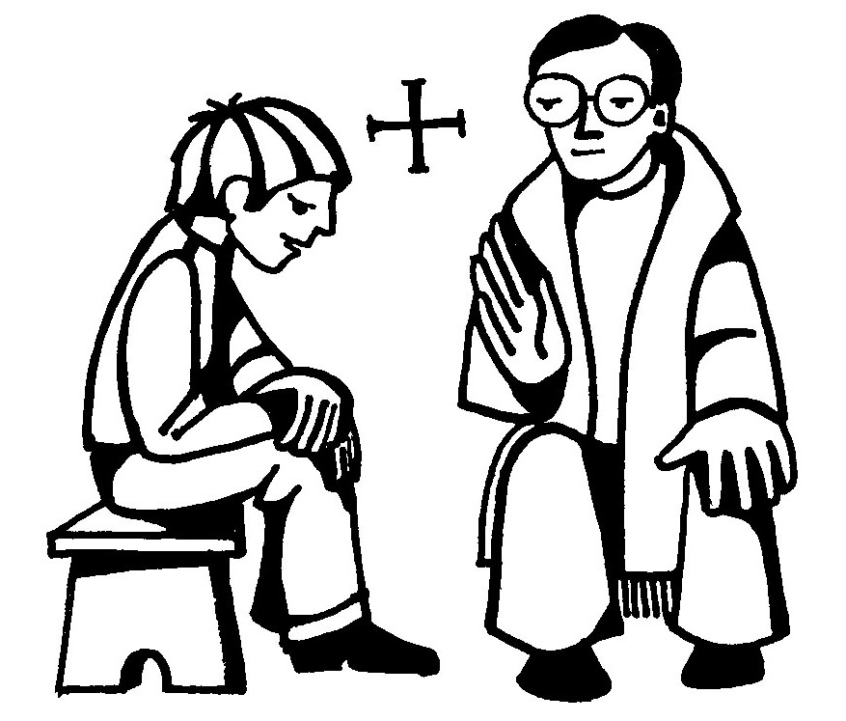
“There is no limit to God’s grace, nor to God’s mercy and forgiveness when we fail. Reconciliation is a sacrament of healing. Reconciliation makes present Jesus’ call to conversion, involves contrition for our sins, confession of them to a priest, and absolution spoken by the priest in the name of Jesus Christ. In the celebration of the sacrament we acknowledge (confess) God’s holiness and mercy and are reconciled to God and the community of the Church.” Religious Education Curriculum Directory

Year 5 will learn that sin is a failure of love and learn that when we sin we hurt ourselves and others and damage our relationship with God. They will begin to understand that God loves and forgives us if we are truly sorry and learn that God heals our friendship with him and others through the Sacrament of Reconciliation. They learn how we can prepare ourselves to receive this Sacrament and learn what happens during the Sacrament of Reconciliation.
At Home
You could help your children by:
• talking to them about what strengthens their friendships
• reading the stories of Jesus’ last week with them

Year 6 – Jesus, Son of God
God’s Self-Revelation and the covenant relationship reach their fullness in Jesus Christ, the only-begotten Son of God. He is truly God and, as a man, truly human. His life, death and resurrection are the central event of all human history and at the heart of faith. His cross is the sign of his unique offering of himself for each and every human being. As truly God, Jesus reveals the truth and love of God; as truly human, Jesus reveals the perfect response to God and intimate communion with his Father – ‘Abba’.”
Religious Education Curriculum Directory

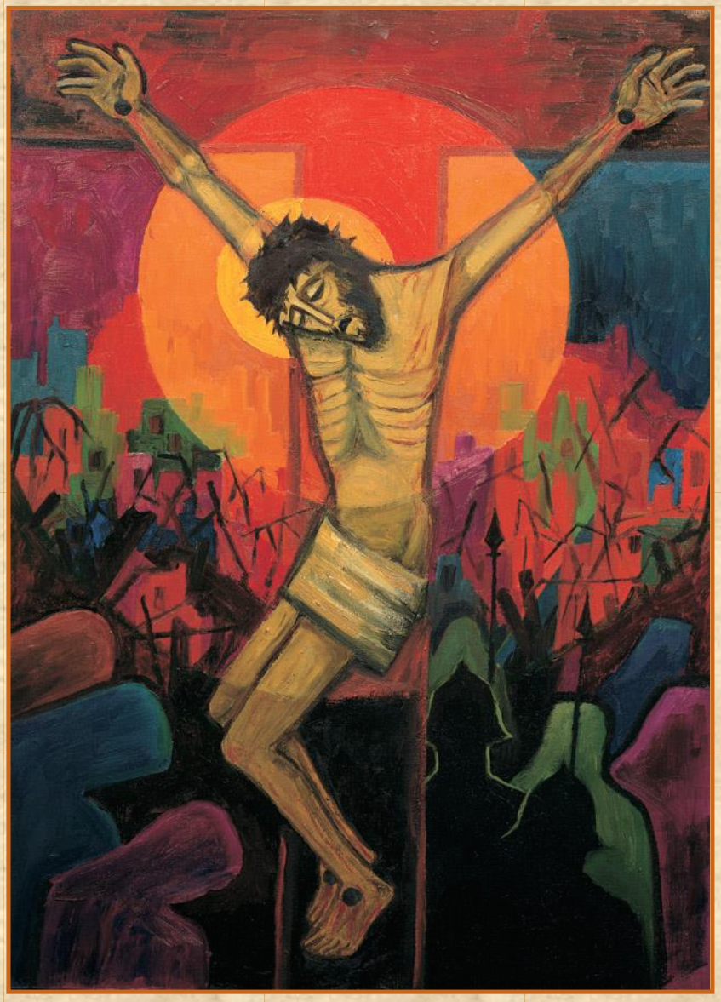
Year 6 will learn that Jesus healed many people, brought others back to life and that His miracles led many to believe that he was the Son of God. They will learn that Jesus’ enemies plotted to have him arrested, and learn about the arrest and the trial before the high priest. They will learn about Jesus’ trial before Pilate and learn that Jesus was condemned to death and crucified. They will also learn what Jesus said before he died and about His glorious resurrection. The children will have the chance to reflect on the miracles of Jesus. They will have the opportunity to make the Stations of the Cross and participate in a dramatisation of the passion, death & resurrection of Jesus. They will also reflect on the meaning of the passion, death and resurrection of Jesus for us today.

At Home
You could help your children by:
•visiting www.tere.org/interactive_site/KS2link
• discuss what they have found out in class and how it will affect their life journey.
• look at the Stations of the Cross and talk about their relevance for us today.

